Project Design Phase-II
Data Flow Diagram & User Stories
Date | 30 September 2026
Team ID | SWUID2026286057
Project Name | Implement Client Script & UI Policy (Incident)
Maximum Marks | 4 Marks
Data Flow Diagrams:
A Data Flow Diagram (DFD) is a visual representation of the information flows within a system. The diagram below shows how the agent's actions on the Incident form and list flow through the UI Policy and Client Script processes, which data stores they read and write, and where validation errors are returned to the user.
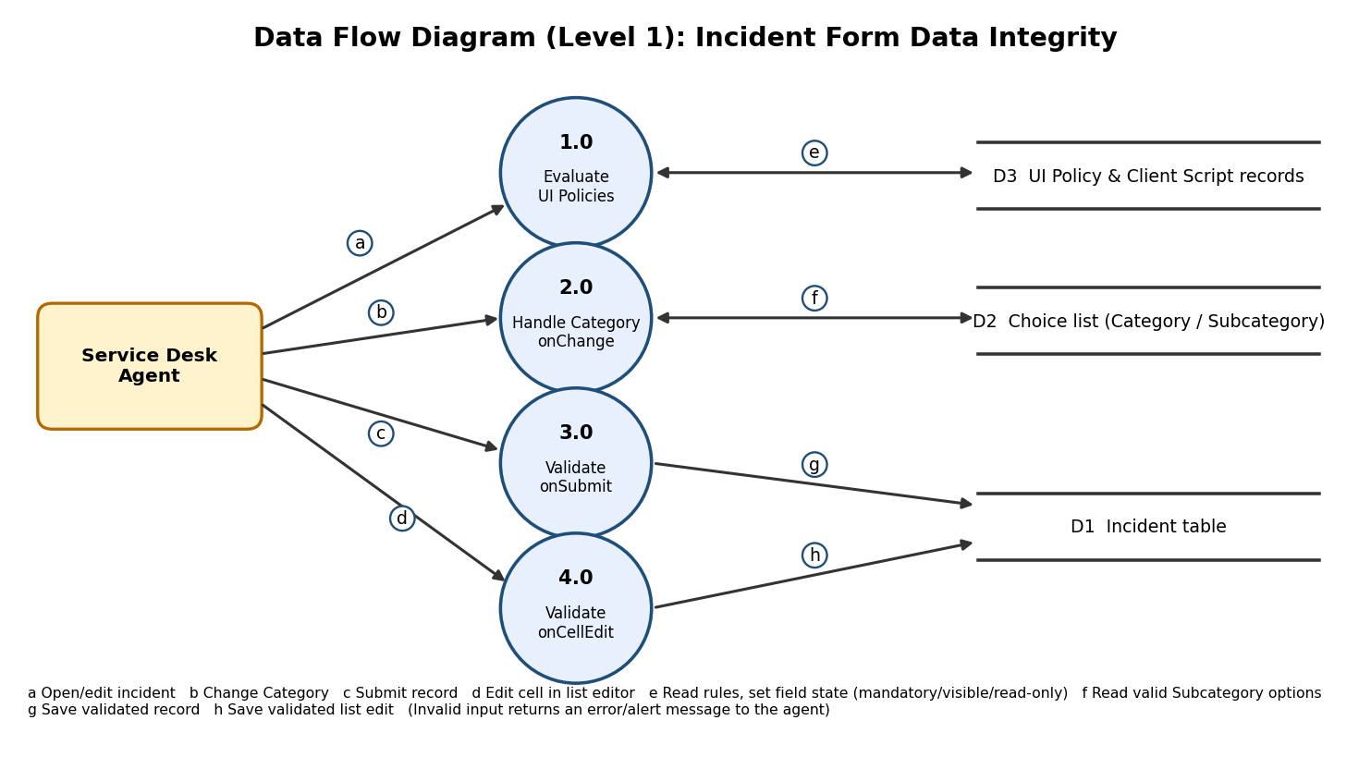
User Stories
User stories for the Incident Client Script and UI Policy product:
User Type | Functional Requirement (Epic) | User Story Number | User Story / Task | Acceptance criteria | Priority | Release
Service Desk Agent | Field State Control (FR-1) | USN-1 | As an agent, I want Assignment group and Description to become mandatory when Impact and Urgency are both High, so critical incidents are routed and documented properly. | With Impact = 1 - High and Urgency = 1 - High, both fields show the mandatory indicator and the form cannot be saved without them. | High | Sprint-1
Service Desk Agent | Field State Control (FR-1) | USN-2 | As an agent, I want the extra fields to return to normal when the condition is no longer true, so the form does not stay cluttered. | Changing Impact or Urgency away from High removes the mandatory status (Reverse if false). | Medium | Sprint-1
Service Desk Agent | Urgency Field Control (FR-2) | USN-3 | As an agent, I want Urgency to become read-only once an incident is Resolved or Closed, so closed records are not altered. | With State = Resolved or Closed, the Urgency field is read-only. | High | Sprint-1
Service Desk Agent | Dependent Field Handling (FR-3) | USN-4 | As an agent, I want Subcategory to reset when I change Category, so I never save a mismatched pair. | Changing Category clears Subcategory and the choice list shows only valid options. | High | Sprint-2
Service Desk Agent | Submission Validation (FR-4) | USN-5 | As an agent, I want a clear error message if I submit without key fields, so I can fix them immediately. | Submitting with an empty Short description or Category is blocked, an error message is displayed and the form stays open. | High | Sprint-2
Service Desk Agent | List Editing Safety (FR-5) | USN-6 | As an agent, I want list edits validated, so I cannot accidentally blank required fields or close incidents from the list. | Inline edits that clear a value or set State to Resolved / Closed are rejected with an alert. | Medium | Sprint-3
Administrator | Maintainability | USN-7 | As an administrator, I want all changes captured in an Update Set and documented, so they can be promoted and audited. | Update Set contains all UI Policies, UI Policy Actions and Client Scripts. | Medium | Sprint-3

